1. Create a Bugzilla account using your college or personal email, then log in and take a screenshot of your Bugzilla dashboard after successful login.
Ans:
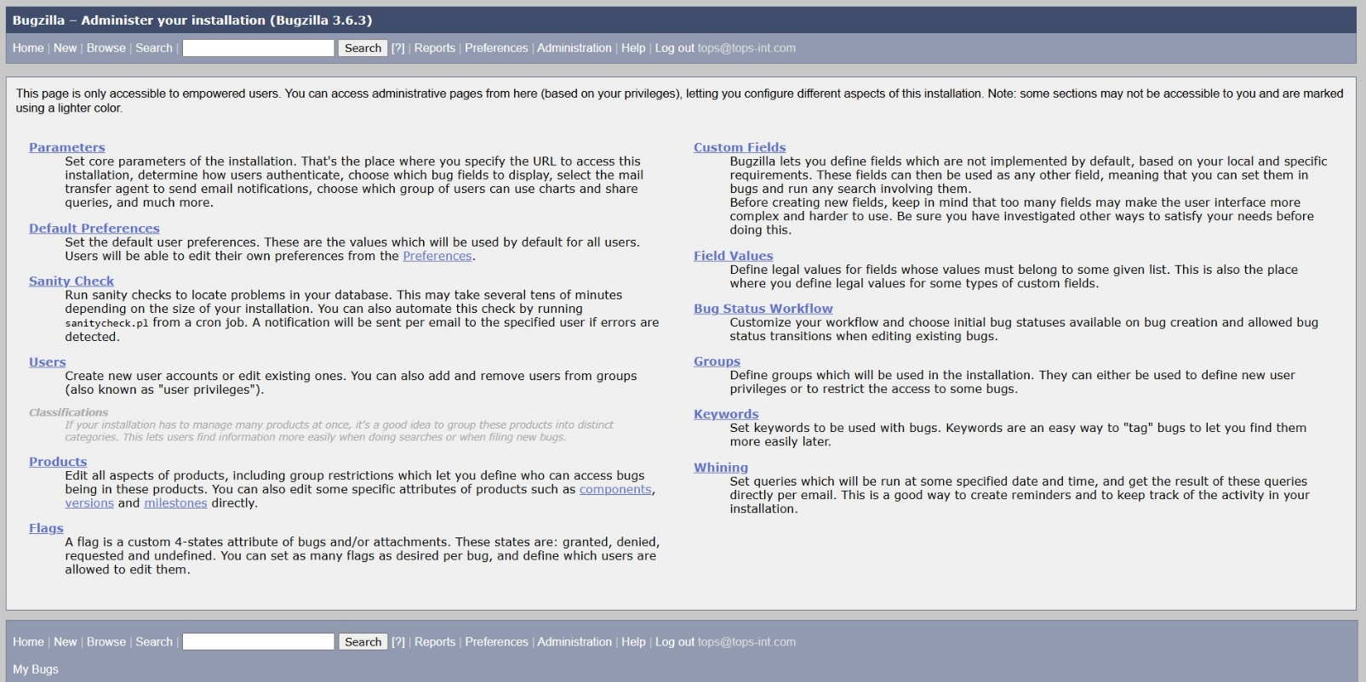

2. Pick any mobile app you use daily (such as Instagram, Zomato, or Paytm) and identify a real or imagined bug you have experienced — log this bug in Bugzilla with a clear summary, detailed steps to reproduce, expected vs actual result, and attach a screenshot or mock image showing the issue.
Ans: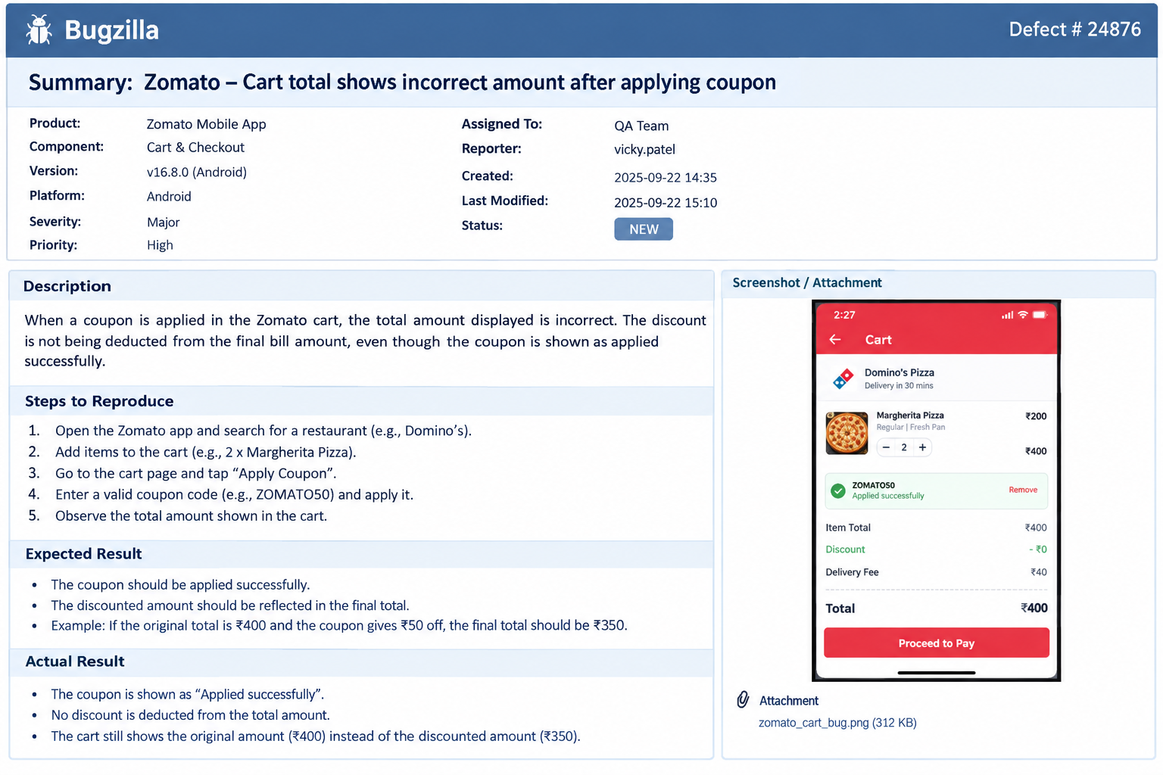
Bugzilla Defect Report
Application: Zomato Mobile App
Module: Cart & Checkout
Platform: Android
Severity: Major
Priority: High
Status: NEW
Summary
Zomato – Cart total shows incorrect amount after applying coupon
Description
When a valid coupon is applied in the Zomato cart, the coupon is shown as successfully applied, but the discount is not deducted from the final payable amount.
Steps to Reproduce
- Open the Zomato mobile app.
- Search for a restaurant and add items to the cart.
- Open the cart and select Apply Coupon.
- Enter a valid coupon code, such as ZOMATO50, and apply it.
- Observe the total amount displayed in the cart.
Expected Result
The coupon should be applied successfully and the discount should be deducted from the final amount. For example, a ₹400 order with a ₹50 discount should show a final amount of ₹350, excluding any applicable additional charges.
Actual Result
The coupon displays “Applied successfully”, but the discount remains ₹0 and the cart continues to show the original amount of ₹400.
Attachment
Screenshot: zomato_cart_bug.png – shows the coupon marked as applied while the discount remains ₹0 and the total is unchanged.

3. Log two more defects in Bugzilla for different apps (for example, a payment failure in PhonePe or a wrong item added in Flipkart cart), making sure to select appropriate Severity and Priority for each defect and fill out the Module and Build/Version fields.
Ans:
Defect 1 – PhonePe Payment Failure
Application: PhonePe
Module: UPI Payment / Checkout
Build/Version: v8.4.2 (Android)
Platform: Android 14
Severity: Critical
Priority: Highest
Status: NEW
Summary
PhonePe – UPI payment fails after entering correct PIN, but amount is debited
Description
A UPI payment may fail after the user enters the correct UPI PIN. In the reported scenario, the transaction screen shows a failure message even though the amount has been debited from the user's bank account.
Steps to Reproduce
- Open the PhonePe application.
- Select Send Money and choose a UPI contact.
- Enter an amount of ₹1,000.
- Confirm the payment.
- Enter the correct UPI PIN.
- Wait for the transaction result.
Expected Result
The payment should be completed successfully and the transaction status should be shown as Successful.
Actual Result
The app displays “Payment Failed”, while the ₹1,000 amount is debited from the bank account.
Impact
The user may experience financial uncertainty and may attempt the payment again, potentially causing a duplicate transaction.
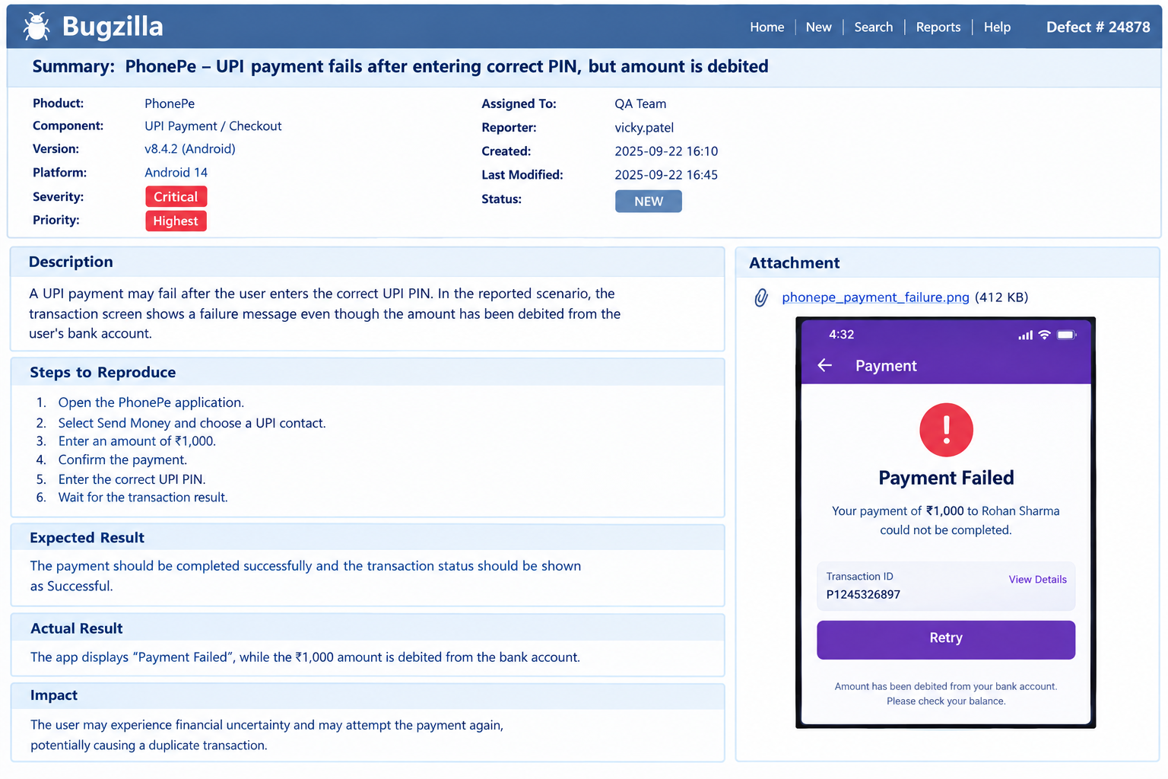Defect 3 – Flipkart Wrong Item Added to Cart
Application: Flipkart
Module: Product Listing / Shopping Cart
Build/Version: v15.7.0 (Android)
Platform: Android 14
Severity: Major
Priority: High
Status: NEW
Summary
Flipkart – Selecting a product variant adds a different variant to the cart
Description
When a user selects a specific product variant, such as a particular size or storage option, the cart sometimes contains a different variant from the one selected on the product page.
Steps to Reproduce
- Open the Flipkart application.
- Search for a product with multiple variants.
- Open the product details page.
- Select a specific variant, for example 128 GB / Blue.
- Tap Add to Cart.
- Open the shopping cart.
- Check the product variant displayed in the cart.
Expected Result
The cart should contain exactly the variant selected by the user, such as 128 GB / Blue.
Actual Result
A different variant, such as 256 GB / Black, is added to the cart.
Impact
The user could accidentally purchase the wrong product variant, leading to order cancellation, returns, and customer dissatisfaction.
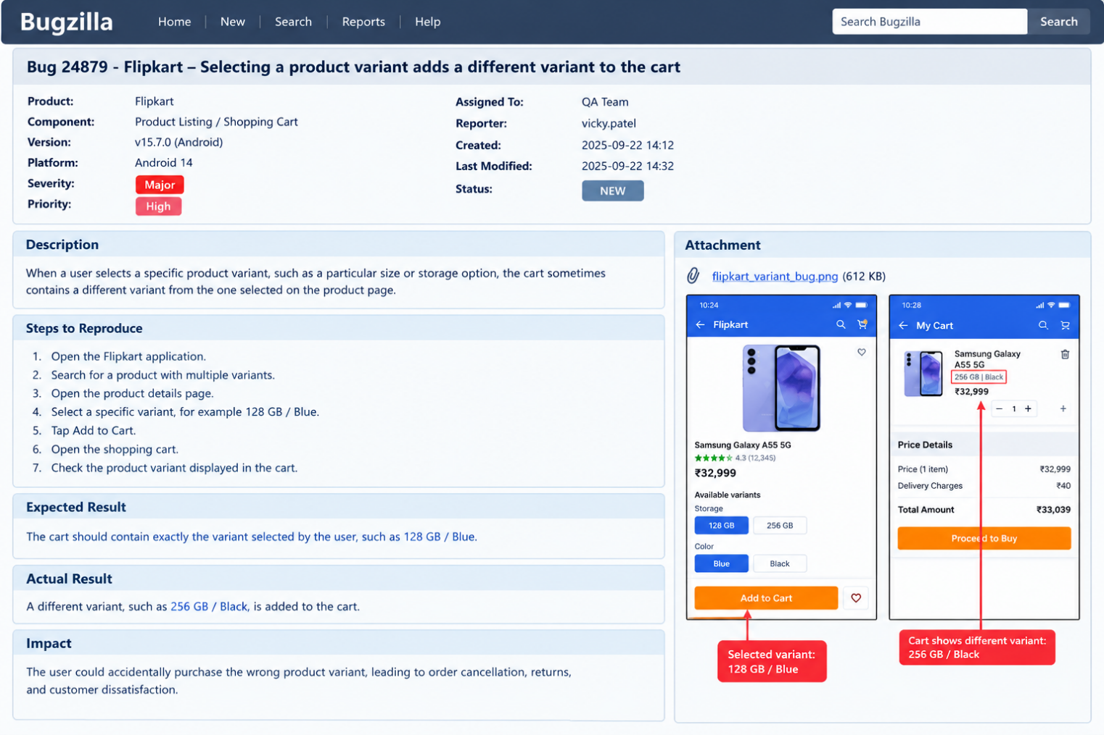
4. Update the status of one of your logged defects in Bugzilla from 'New' to 'Assigned', then to 'Fixed', 'Retest', and finally 'Closed', adding a brief comment at each stage describing what happened.<br><br><em><strong>Hint:</strong> Use the 'Add Comment' box in Bugzilla to note what action was taken at each step.</em>
Ans:
Use Defect #24879 – Flipkart wrong product variant added to cart for this workflow.
Bugzilla status update sequence
Stage | Status | Comment to add in Add Comment box
1 | New | Initial defect logged. The issue was reproduced successfully where selecting 128 GB / Blue resulted in 256 GB / Black being added to the cart.
2 | Assigned | Defect assigned to the QA/Development team for investigation and correction of the incorrect product-variant mapping.
3 | Fixed | Fix completed. The product variant selection and cart-mapping logic was corrected, and the updated build is ready for QA verification.
4 | Retest | Retesting performed. The selected 128 GB / Blue variant was added to the cart correctly, and the incorrect-variant issue could not be reproduced.
5 | Closed | Defect verified and closed. The fix passed retesting and the expected product variant is now displayed correctly in the cart.
How to update it in Bugzilla
Open Bug #24879 → change Status to Assigned → enter the comment → click Save Changes. Repeat the same process for Fixed → Retest → Closed, adding the corresponding comment at each stage.
For your assignment, the final defect lifecycle will be:
New → Assigned → Fixed → Retest → Closed

5. Use Bugzilla's search and filter features to find all defects you have logged that are currently not 'Closed', and take a screenshot showing the filtered results.<br><br><em><strong>Hint:</strong> Try filtering by your user ID and by defect status.</em>
Ans:
